ECU Health Management System

Functional Description

This document defines the ECU Health Management system. The ECU Health Management System (HMS) stores very detailed information related to module faults which will facilitate root causing failures and malfunctions as well as accessing the health of the IPC in the field. ECU Health Management System Monitoring is intended to capture the health statistics information of the IPC in to a package (set of files called System Health Report) in the non-volatile memory (NAND). The following primary functions are provided:
- Failure detection and recovery
- Error detection and recovery
- Event logging
- Reporting

Fault conditions detected include abnormal module resets, module lock-ups, processes which terminate abnormally, processes that take too long to execute, and so on.

This fault information is recorded in non-volatile memory (NAND) and then extracted from the module using diagnostic commands (via the Diagnostics API provided by Ford Core SW team). For a given fault, the module will store information such as the date and time when the fault occurred, the software call stack when the fault occurred, the reason for the reset (e.g., low voltage, etc.)

It is realized that this function is highly dependent on the supplier hardware and software architecture. Thus, this STSS is written generically for both single and dual micro architectures, and seeks to define a minimal set of requirements that would be applicable to any cluster. Supplier is expected to extend these requirements to fully cover their architecture.

As an overview (and this will vary by cluster and vehicle architecture), the HMS (which includes the diagnostics) will be a client of the SOA gateway and use the same security model. The data is encrypted via the SOA, and the data will be offloaded to the ECG before going up to the cloud. Typically SFTP or OVTP is used to transfer data to the ECG, and using SOA for security.

Interfaces

Interface Context Diagram (I/O Block Diagram)
Health Monitoring Interface Context Diagram
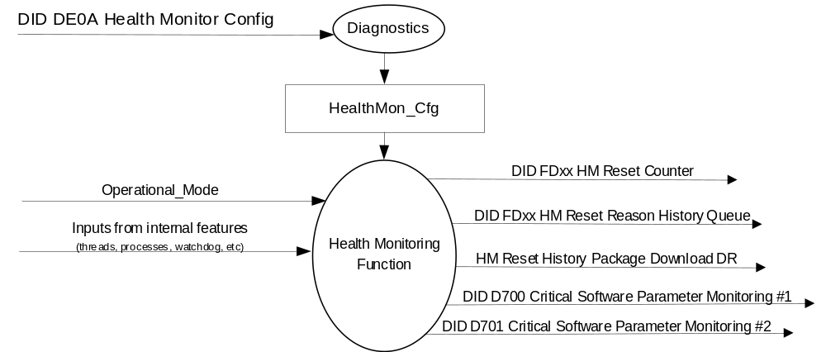

Inputs

      - INTERNAL:
- Operational_Mode
- Inputs from internal features (threads, processes, watchdog, etc)

Outputs
- DID $FDxx HM Reset Counter
- DID $FDxx HM Reset Reason History Queue
- HM Reset History Package Download DR $xxxx
- DID 0xD700 Critical Software Parameter Monitoring #1 (Refer to ECU SW Design Rules from Software eSOW – Included in the STSS to ensure that DID is supported)
- DID 0xD701 Critical Software Parameter Monitoring #2 (Refer to ECU SW Design Rules from Software eSOW – Included in the STSS to ensure that DID is supported)

Function/Performance

Operational Modes

Mode | Differentiating Vehicle Conditions
Sleep Mode | Health Monitoring OFF
Limited Mode | Health Monitoring ON / HM Diagnostics OFF
Normal Mode | Health Monitoring ON / HM Diagnostics ON
Crank Mode | Health Monitoring ON / HM Diagnostics ON

Voltage Levels

Refer to the Cluster Features table located in Operational Modes and Voltage Range Strategies Section in this SPSS.

Human-Machine Interface

Visual

None

Audio

None.

System Accuracy

The Health Monitoring system shall log fault data into RAM within 100msec of detecting an issue as indicated in the state matrix reference 1.3.5.1 Subsystem Algorithm Flowchart/ State Diagram

Operation: Performance and Functional

Subsystem Algorithm Flowchart / State Diagram

Health Monitor Configuration

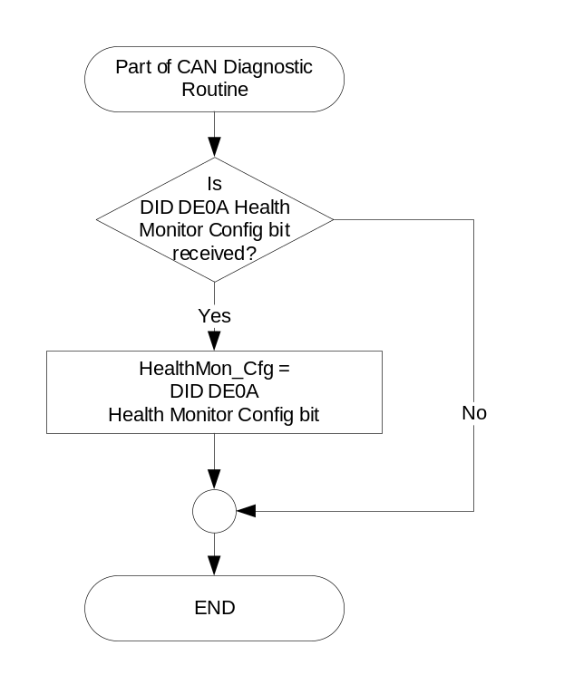

State Matrix for Health Monitoring
HealthMon_Cfg | Expected Monitoring
Disabled (0x0) | No Health Monitoring should be done on the cluster.
Enabled (0x1) | Health Monitoring should be enabled on the cluster.  - For a single-processor cluster, only the VIP (Vehicle Processor) should be monitored.  - For a multi-processor cluster, both VIP (Vehicle Processor) and GIP (Graphics Processor) should be monitored.

Health Management Features
Feature | Description
Failure detection and recovery | Detection and recovery of a system condition that requires a full reset to recover.
Error detection and recovery | Detection and recovery of a system condition where a recovery action is required but an IPC reset is NOT required, minimizing the impact to the end user.
Event logging | Logging of a system condition for which the occurrence should be recorded for later analysis. This type of condition does not require any corrective action.
Reporting | Generation of a System Health Report, which shall contain all the necessary data for later root cause of the condition/issue.

Monitoring – Failure Detection and Recovery Functions
Detection and Recovery Functions | Examples
Failures | Unsuccessful restart (multiple attempts) of a crashed or unresponsive process or thread  - Unique failure codes identify each thread/process
 | Low system memory
 | Lost VIP-GIP communication
 | VIP Watchdog reset
Errors | Successful restart of a crashed or unresponsive process or thread
 | Start of a process that was not properly started
Design Implications | Resynchronization with processes for which data is transferred to/from the failed process  - Facilitated by the centralized monitoring component (HealthMonitor) and the GIP inter-process communication infrastructure (ITC)
 | Reentrant design of components

Monitoring – Event Logging Types
Event | Examples
Mis-synchronized states | Display backlight off when ignition is on
 | Missed animation complete event
System events | Late startup/check-in of component
 | High CPU usage by a particular component
 | Queue exceeds threshold
 | Late ping/pong exchange
 | Calibration not available/invalid
 | Invalid data from another ECU

Examples of Monitoring Types
Monitoring Type | Description
Watchdog timer monitoring | Monitor and log watchdog timer resets
Alive supervision | Check that a process / task / thread is executing within the proper time tolerance
Deadline supervision | Check that the execution time between two checkpoints is lower than a maximum limit
Logical supervision | Check that software is being executed in the proper sequence, as specified during development
Monitoring CPU Usage above a given threshold | Monitor when CPU Usage is above a given threshold
Memory monitoring | Monitor when Available Memory drops below a given threshold
VIP / GIP processor communications link monitoring | Monitor VIP / GIP processor communications link
RTOS (Autosar / QNX) fault monitoring | Monitor and log operating system faults
Voltage monitoring | Monitor resets caused by voltage drops

Key Configuration Parameters
Configuration Name | Description
Delay | The amount of time in seconds that check-in monitoring of the component will initially be delayed.
Crash check delay | The amount of time in milliseconds that crash monitoring of the component will initially be delayed.
Check-in Timeout | The amount of time in seconds that a component has to check-in before an error occurs.
CPU Usage Threshold | When CPU usage exceeds the threshold, events are logged to the health Report Log.
Monitor Mode | Don't monitor, crash only, check-in only, check-in and crash.
Restart Type | Do nothing, restart the process (do not reset board), reset the entire board.
Restart Threshold | The number of times in one ignition cycle a process is allowed to restart before resetting the board.

Check-in Times and Thresholds
Check in Time / Threshold Type | Initial Value
Check-in | 1 second
Monitoring frequency | 2 seconds
Check-in failure | 6 seconds
Crash Detection | 250 milliseconds  (not configurable)
Low Memory Check | 2 seconds
CPU usage check | 1 second

Reset Reasons
Byte Value | Reset Reason | Description
0x00 | No Running Reset
0x01 | Undefined (Reserved)
0x02 | External Watchdog Timer
0x03 | Internal Watchdog Timer
0x04 | Unidentified Unhandled Interrupt or Exception
0x05 | A Running Reset Invoked by the Secondary Processor (if present)
0x06 | Undefined (Reserved)
0x07 | Requested by Software Via FORCE_RUNNING_RESET Interface
0x08 | Uncorrectable Flash Memory Error (Error Correction Circuit Error)
0x09 | Time Processor Unit Signature Error
0x0A | Request Response Security Monitor Excessive Error Count
0x0B | Request Response Security Monitor RAM Test Failure
0x0C | Request Response Security Monitor ROM Test Failure
0x0D | Uncorrectable RAM Error (Error Correction Circuit Error)
0x0E | Uncorrectable Cache Memory Error (Parity Error)
0x0F | UNDEFINED
0x10 | POWER ON RESET
0x11 | LOW VOLTAGE RAM RETAIN RESET
0x12 | INITX RESET
0x13 | ILLEGAL MODE RESET
0x14 | EXTERNAL RESET
0x15 | LOW VOLTAGE INTERNAL RESET
0x16 | LOW VOLTAGE INTERNAL EXTRA RESET
0x17 | LOW VOLTAGE EXTERNAL RESET
0x18 | LOW VOLTAGE EXTERNAL EXTRA RESET
0x19 | CLOCK STOP WAIT RESET
0x1A | SRSTX RESET
0x1B | PROFILE ERROR RESET
0x1C | WATCHDOG RESET
0x1D | WATCHDOG SW RESET
0x1E | SW RESET
0x1F | SW TRIGGER HW RESET
0x20 | SLOW CR CLOCK STOP RESET
0x21 | FAST CR CLOCK STOP RESET
0x22 | MAIN CLOCK STOP RESET
0x23 | SUB CLOCK STOP RESET
0x24 | PLL0 STOP RESET
0x25 | PLL1STOP RESET
0x26 | PLL2 STOP RESET
0x27 | PLL3 STOP RESET
0x28 | SSCG0 STOP RESET
0x29 | SSCG1 STOP RESET
0x2A | SSCG2 STOP RESET
0x2B | SSCG3 STOP RESET
0x2C | WAKEUP RESET
0x2D – 0xFF | Undefined (Reserved)
Note: Supplier shall attempt to use the suggested reasons above before using the “Undefined” states.

Operation Description (supports algorithm flowchart /state diagram)

- GIP (Graphics Interface Processsor)
  - Both processes and threads shall be monitored
    - Shall monitor processes and threads running on the GIP
    - Shall monitor that the VIP is still functional – using a periodically exchanged Ping/Pong messages
  - Monitoring shall be initiated by the monitoring system rather than by the process/thread
  - Shall detect crashed and unresponsive processes and threads
  - Shall coordinate restart and synchronization of failed components without full IPC RESET
    - No special component logic to accomplish restart/re-sync
  - Shall be fully configurable
  - Reports shall be initially stored in RAM file system and copied to non-volatile memory (if available) when
    - crash detected
    - process restart required
    - IPC reset

- VIP (Vehicle Interface Processor)
  - Shall monitor that the GIP is still functional – using a periodically exchanged Ping/Pong messages
  - Shall have H/W watchdog

- Hardware/System Requirements
  - Persistent data storage (i.e. NAND)
  - Access to high speed data port to support access to both stored diagnostic data and run-time profiling data
    - Cluster specific, agreed upon during sourcing (HSCAN or Ethernet)

- All Cluster Tier I supplier processes shall be monitored
- A subset of threads and 3rd party processes shall be monitored based upon criteria set by project architect
  - >90% of threads shall be monitored
  - Examples of 3rd party processes that shall be monitored
    - mqueue
    - screen
    - Slogger

- Unrecoverable faults shall cause a reset of the VIP or GIP, as required to recover the cluster operation.
- A HM Reset Counter shall be maintained, indicating the number of times a fault has caused the cluster to reset. It is acceptable to implement a single counter for VIP and GIP resets.

- A HM Reset Reason History Queue shall be maintained for historical purposes, containing reasons for the most recent 10 reset events. It is acceptable to implement a single queue for VIP or GIP reset reasons, with different reset reason IDs for the two micros.

- Reporting - The System Health Report shall contain all the necessary data for later root cause of the condition/issue (including Real Time timestamp and other details), including:
  - Core dump
    - in case of crash or unsuccessful process restart
  - Health Report Log – output of System Monitoring (failures, errors, events)
  - CPU statistics (CPU load, mqueue size, memory information, process information)
  - Slogger info

- Along with the cause of the reset, any additional data shall be saved in a data log. The data log format and retrieval mechanisms shall be determined by each cluster supplier, and these supplier specific diagnostics shall be documented in the Part II spec.

- All Personally Identifiable Information (PII) shall be stripped out of the log files before storage to the data log.

- System information shall be gathered prior to resetting the VIP / GIP if possible (e.g. core files, log files), and could include:
- The reason for termination (i.e. illegal memory access).
- The task that was active when the fault occurred.
- The current location of the program when the fault occurred.
- Call stack and stack frames.
- Relevant control registers

- For example, the following information may need to be included in the "Core Dump":
- Call Stack
- Data RAM
- Processor registers:
  - PC
  - SP
  - LR
  - GPRs
  - System Control Registers
  - Interrupt Control Registers
  - Program Status Register
  - Exception and Reset Control Registers

Function Safety Classification (EMC)

B

Memory Storage

Parameter Name | Description | Value at  Battery Connect | Value at  Module Wake-up
HealthMon_Cfg | Configures the cluster to determine whether the Health Monitoring feature is active.  - Disabled (0x0)  - Enabled (0x1) | Use Stored Value | Use Stored Value
Operational_Mode | 4 state indicator for cluster operational mode | Limited | Limited, Normal or Crank

Prove Out

None

Reconfigurable RTT

None.

Message Center Msg

None

Error Handling

Missing Message Strategy

None

Diagnostics

Self Test

None

Engineering Test Mode

Reference section “Dealer / Engineering Test Mode (ETM)”

Part II Performance

Supported Diagnostic DIDs (Service $22)
Number | PID / CommonID Name | Bytes | DID Type | Comments
$FDxx | HM Reset Counter | 2 | Numeric | Supplier Range:  Number of detected running resets since the last reprogramming
$FDxx | HM Reset Reason History Queue DID | 10 | SED | Supplier Range:  Most recent 10 reset reasons are to be reported, in order of most recent to least recent.  For more details, see Table 3 Reset Reasons.
**Note: Additional diagnostics (DIDs / DRs / etc) should be provided by each supplier as required to download reset data logs, as necessary.

Supported Diagnostic Trouble Codes (DTCs)

DTC | Description | When Logged
None

DID DExx
Block  Num | Block Description | Size  (bits) | Type | Byte(s) | Bits | State: Description | "0" | "1" | Default | Comments/  Information
PACKETED BLOCKS
$0A | Option Content (B&A) | 1 | 1 | * | * | Health Monitor Config | Disabled | Enabled | Enabled
*Byte and bit location to be identified in Part II Specification for this cluster

Reference Specification

Revision History

SPSS Module Revision History

Revision Level | Name | Change Description | Date
1.0 | S.Watkins | Initial Release. (With a great deal of assistance from Dhende47 at Visteon) | 8/20/2018

